Janet Izzo Awarded 2018 CNYWBA Karen DeCrow Award
At its Annual Meeting on April 12, 2018, the Central New York Women’s Bar Association presented the second annual Karen DeCrow Award to Janet M. Izzo, Esq. The award honors a member of the judiciary or legal profession who works to advance the principles that Karen promoted throughout her life – justice, feminism and social equality for all races, creeds, ethnicities and sexual orientations.
Janet’s personal story is awe inspiring. She began working as a secretary at a law firm in 1988. Realizing that she was more than capable of handling cases herself, she attended SUNY Oswego part-time and at night, to earn her bachelor’s degree. She then attended Syracuse University College of Law, while still working, to earn her Juris Doctor. While she was there, she was an editor of the Syracuse Law Review. Janet did all of this while not only working, but also caring for her family and successfully raising her three children.
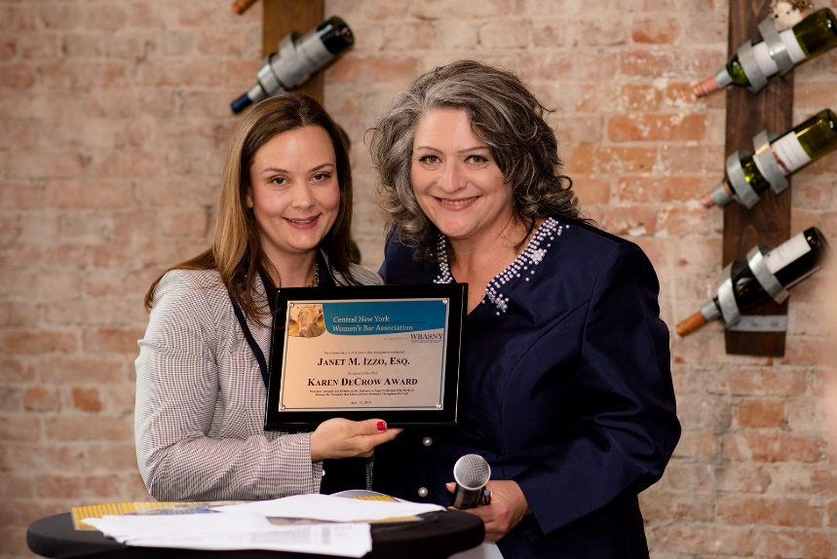
After graduating from law school, Janet returned to work at the same law firm, until her path eventually led to her opening a solo practice. She claims she did so when she realized that she was the best person to sit first chair and she did not need to rely on anyone else to try her cases. She is a successful female solo practitioner in an area of law that is dominated by men and large law firms.
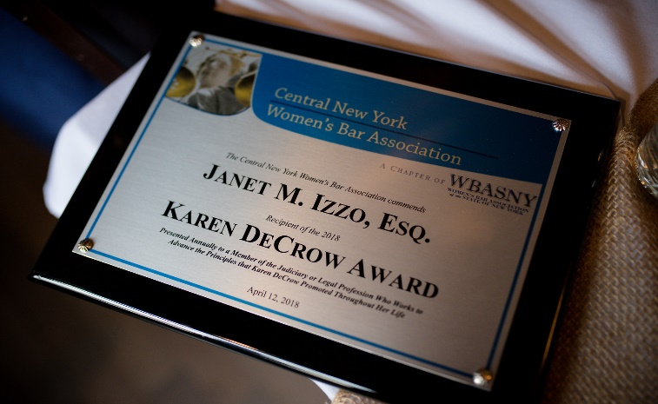
In addition to the full-time practice of law, Janet has donated her time and expertise to other legal endeavors, most notably serving as a volunteer attorney for Vera House, helping those affected by domestic and sexual violence. She is also involved in a number of professional organizations, including but not limited to The American Association for Justice, the New York State Academy of Trial Lawyers, the Onondaga County Bar Association, the Onondaga County Bar Foundation (of which she is a board member), and the Women’s Bar Association of the State of New York. She has volunteered her time representing clients pro bono through the Say Yes Pro Bono Clinic. Her practice focuses on medical malpractice, where she works tirelessly to protect those injured by the negligent acts of others, including women and children. Janet’s contributions to our own organization are also impressive. She served as a board member for many years, culminating in her tenure as president of the CNYWBA from 2005-2006. Since that time, she has remained an active participant in our organization, attending functions and events, serving on committees, and offering her invaluable guidance.
Through her example, Janet has shown what is possible with hard work, grit, and determination. She is confident in her own abilities and has blazed her own path to success and respect in our legal community. On top of these achievements, she still finds time to mentor young attorneys, volunteer, and give back to the community. Janet has consistently worked to improve the legal profession for women, making it just a little easier for those who come next. Janet embodies the spirit and promise of the Central New York Women’s Bar Association and the principles that Karen DeCrow promoted.

