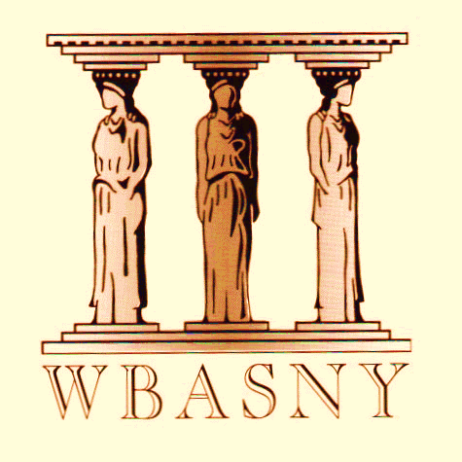 | Central New York  Women’s Bar Association  A Chapter of the Women’s Bar Association of the State of New York  P.O. Box 408, Syracuse, NY 13201-0408
Shannon O’Connor  President  Jillian McGuire  President-Elect  Annaleigh Porter  Vice President  Brittany Hannah  Treasurer  Colleen Gibbons  Secretary  Laurel J. Eveleigh  Immediate Past President  DIRECTORS  Samantha Aguam  Taylor Baker  Amy D’Ambrogio  Courtney DeLia  Suzanne Galbato  Hon. Deborah Karalunas  Rosemary Lepiane  Sara Lowengard  Maureen Maney  Nicole Marmanillo  Janet Moon  Erin Phillips  Samantha Riggi  Kelsey Shannon  Kathryn Strodel  Melissa Swartz  Leah Witmer  Jane Zhang  EX OFFICIO  Hon. Rosemary Pooler | NOTICE OF ANNUAL MEETING  PLEASE TAKE NOTICE, that the Annual Meeting of Members of the Central New York Women's Bar Association (the "CNYWBA") will be held virtually on Wednesday, April 28th, 2021 at 12:00 p.m.  The Zoom info is as follows:  Topic: CNYWBA Annual Meeting  Time: Apr 28, 2021 01:00 PM Eastern Time (US and Canada)  Join Zoom Meeting  https://Courtinnovation.zoom.us/j/98120510600  Meeting ID: 981 2051 0600  One tap mobile  +19294362866,,98120510600# US (New York)  +13017158592,,98120510600# US (Washington DC)  Dial by your location  +1 929 436 2866 US (New York)  +1 301 715 8592 US (Washington DC)  +1 312 626 6799 US (Chicago)  +1 346 248 7799 US (Houston)  +1 669 900 6833 US (San Jose)  +1 253 215 8782 US (Tacoma)  Meeting ID: 981 2051 0600  The purpose of the meeting is to:  1) Elect CNYWBA officers and directors for the 2021-2022 term;  2) Elect the Women's Bar Association of the State of New York  ("WBASNY") officers for the 2021-2022 term;  3) Approve the minutes of the 2019-2020 Annual Meetings; and  4) Transact such other business as may be properly brought before the  Annual Meeting.  ITEM I: ELECTION OF OFFICERS AND DIRECTORS TO CNYWBA FOR 2021-2022  Pursuant to Article VI, Section 1 of the CNYWBA By-Laws, the Nominations Committee has proposed the following slate for Officer and Board of Director positions for the 2021-2022 term:  OFFICERS  President Jillian McGuire  President-Elect Annaleigh Porter  Vice President Leah Witmer  Treasurer Sara Lowengard  Secretary Brittany Hannah  COMMITTEES  Membership Colleen Gibbons  Judicial Reception Samantha Riggi  Judicial Screening Suzanne Galbato  DIRECTORS AT-LARGE (6) Amy D’Ambrogio  Courtney DeLia  Hon. Deborah Karalunas  Rosemary Lepiane  Alicia Loomis  Maureen Maney  Stephanie Martin-Thom  Melissa Rothbart  Kathryn Strodel  Kimberly Wolf-Price  Jane Zhang  EX OFFICIO  Hon. Rosemary Pooler  Laurel J. Eveleigh  ITEM II: ELECTION OF OFFICERS TO WBASNY FOR 2020-2021  NOTICE IS HEREBY PROVIDED pursuant to Article V and Article XV, Sections 10 and 11, of the WBASNY By-Laws, and the membership is advised as follows:  Under WBASNY’s by-laws, President-Elect Dawn Reid-Green (Staten Island) will automatically assume the office of WBASNY President for 2021-2022, and President Joy A. Thompson (Brooklyn) will assume the office of Immediate Past President. The Nominations Committee nominated the following slate of officers for the 2021-2022 term:  President-Elect Deborah G. Rosenthal (New York)  Vice President Shari R. Gordon (Westchester)  Vice President Dawn A. Lott (Suffolk)  Vice President Marea Wachsman (Brooklyn)  Treasurer Simone Freeman (Nassau)  Corresponding Secretary Kathleen Campbell (Del-Chen-O)  Recording Secretary Madison Porzio (Queens)

2021 CNYWBA Annual Meeting Proxy

IF YOU CANNOT ATTEND THE VIRTUAL ANNUAL MEETING on April 28, 2021, you may use this proxy form to cast your vote:

ITEM I: ELECTION OF OFFICERS AND DIRECTORS
OF CNYWBA FOR 2021-2022

_______ Yes, I vote in favor of the proposed 2021-2022 CNYWBA Officers and Directors.

_______ Yes, I vote in favor of the proposed 2021-2022 CNYWBA Officers and Directors, except:

(list names of individuals for whom you do not wish to vote)

_______ No, I do not vote in favor of any of the proposed 2021-2022 CNYWBA Officers and Directors.

ITEM II: ELECTION OF OFFICERS OF WBASNY FOR 2021-2022

_______ Yes, I vote in favor of the proposed 2021-2022 WBASNY Officers.

_______ Yes, I vote in favor of the proposed 2021-2022 WBASNY Officers, except:

(list names of individuals for whom you do not wish to vote)

_______ No, I do not vote in favor of any of the proposed 2021-2022 WBASNY Officers.

Date: ____________ Signature _____________________________________

Printed Name _____________________________________

Please mail your completed proxy to: Laurel Eveleigh, c/o Alario & Fischer, P.C., 5 Adler Drive, Suite 4, East Syracuse, New York 13057 or scan and email your completed proxy form to CNYWBA@gmail.com.

**Proxies MUST be received on or before April 28, 2021 by 10:00 am**

Important Note: Eligible members may vote in person or by mail (proxy) ballot only. Article XIII, Section 3 of the WBASNY By-Laws provides that eligible members are those who are in good standing (Article XI) and whose dues for the current fiscal year have been received prior to the election. Per Article XI, Section 1, members who are law students, law graduates awaiting admission, or are admitted only outside of New York are not eligible to vote.

